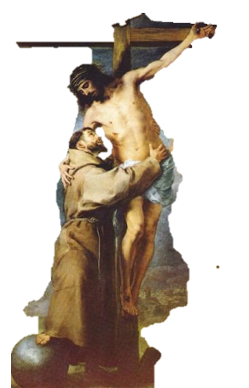
General Commission Communal Reflection No. 10

Witnessing to God’s Love

Introduction
God first loved us. It is this love that ought to impel us to witness
to God’s love in our daily lives.

Song: God You are Good (What You Hold – Cathy T. Nelson)
or other appropriate song

Reading 1: Mark 12: 29-31

The most important one,” answered Jesus, “is this: ‘Hear, O Israel: The Lord our God, the Lord is one. Love the Lord your God with all your heart and with all your soul and with all your mind and with all your strength.’ The second is this: ‘Love your neighbor as yourself.’ There is no commandment greater than these.
Quiet Reflection

Reading 2: Our witness is to be witnesses to God's love (Bishop Thomas Gumbleton)

What we must bring into our world is this gift of God's love ... Sometimes we get examples of people who we would call ordinary people who truly live this kind of love. Just this past week (perhaps you saw it in the news, it probably didn't get a lot of attention), in New York City a police officer was buried.

He had died of a heart attack. But this police officer was someone very special. His name was Steven McDonald and over 30 years ago when he was still a young police officer, two years on the force, he had stopped in Central Park to talk to some teenagers because there had been some bicycle thefts. One of them pulled out a gun and shot him three times, severed his spinal cord. He was paralyzed from the neck down for the rest of his life.

Almost from the very beginning, he proclaimed, "I forgive you." During the rest of his life, over 30 years, paralyzed, having to move about in a very special kind of wheelchair and with a respirator that enabled him to breathe, he traveled around proclaiming the message of God's love. He would go into high schools and teach young people, by his very experience, the message of Jesus because from the very beginning, he forgave the young man who did it and prayed for him. In fact, he had kind of a mantra.

He used to say, "The only thing worse than taking a bullet would be to hold vengeance in your heart, hatred in your heart." He could see that would be worse than what happened to him, if he destroyed himself by hatred in his heart. Now there is an example of love that is amazing. This

ordinary person fulfilling one of the most important service vocations in our society shows us the example of the love of God for us. He and his wife raised their son, who was born just a few months after officer McDonald was shot, to be also someone who could spread the love of God as a police officer. He was at the funeral, of course.

I offer this as an example of what it means. Now this is extraordinary and most of us aren't going to be called to that kind of almost impossible love, but when we look upon someone like that we can at least say, "I can do better in my everyday life.” When all of us really come to understand that this is our call, like that servant in Isaiah, we will be carrying the message of God's love to the very ends of the earth. As we do this faithfully, then God's will for our world will be fulfilled. We will transform our world into the reign of God where there will be peace and fullness of life for every person.

Quiet Reflection

Reading 3: Admonitions of St. Francis - IX True Love

The Lord says: Love your enemies [do good to those who hate you and pray for those who persecute and blame you] (Mt 5:44). That person truly loves his enemy who is not upset at any injury which is done to himself, but out of love of God is disturbed at the sin of the other’s soul. And let him show his love for the other by his deeds.

Quiet Reflection for 10 Minutes
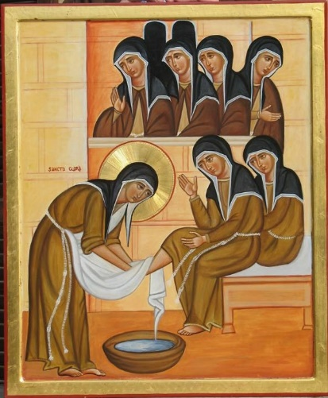

For Reflection
- What message did these readings speak to me/to us today?
- Personally/communally what is stirring within me/us
and being called forth?

Group Sharing

For whom or what shall we pray?

Closing Song: Love Changes Everything (Andrew Lloyd Weber)
or other appropriate song

