General Commission Communal Reflection No. 1

SPIRIT-LED LIFE AND MISSION

Introduction:
Gathering once again in prayer and fraternitas, we desire to deepen our relationship with God, one another, and all of creation by reverencing our commitment and purpose as Spirit-led women of hope, joy and peace.

Opening Reflection: Being in Communion Jan Navotka

Being in communion we are one.
Being in communion; being one.
(sing 4x)

Scripture Reading: Isaiah 43:18-19

Remember not the events of the past, the things of long ago consider not;
See, I am doing something new! Now it springs forth, do you not perceive it?

Quiet reflection

Reading 2: Chapter Statement 2016

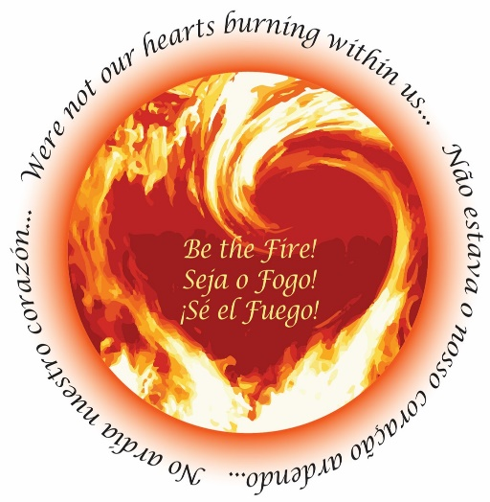
Ignited by the fire of the Spirit and our Allegany Franciscan-Clarian charism, we lovingly gaze on the Source of All Goodness, and consider our mission and witness in the church and the world. We contemplate creation’s clamor for justice and peace; and transformed by the life and ministry of Jesus, we respond. We act as Gospel women and partner with others to generate a culture of peace and integrity, reflecting God’s love for our human family and common home.

Quiet reflection

Reading 3: Clarian Dimensions of Life, Reflection 4: Imitate
Meg Guider, OSF

… What can you do to foster ultimate formation in a Clarian way, that builds on trust, transparency and tenderness, a grace-filled way that is grounded in a renewed sense of presence, passion and purpose – reflective of the reality of your lives at this point in time – a present that reminds us – according to the thought of St. Augustine - of the past that is in the present, the present that is in the present and the future that is the present. As Mary Catherine Bateson observes, “We are not what we know but what we are willing to learn.” The challenge of ultimate formation, it seems to me, parallels the challenge of initial formation: What are we willing to learn – collectively and individually? The bottom line is deciding do we want to be companions on this journey of ultimate formation? Or not? If not, what is the hesitation, resistance or fear? And if so, what is the plan for going about it?

Quiet reflection (10 minutes)
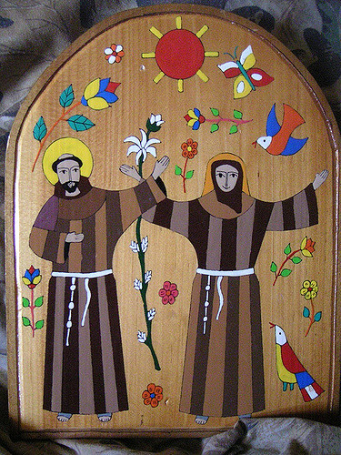
What message do these readings have for me, for us today?
Personally and communally, what is emerging within?
How can I/we be companions on this journey?

Personal notes:

Group Sharing

Closing Prayer: For what do we want to pray … (voice your intentions)

Together: Our Father …

¹Mary Catherine Bateson, Composing a Further Life: the Age of Active Wisdom (New York: Vintage Books, 2010).

